|  |
| --- |
| DBS |
| DealOnline Web Applications Handbook |
| Investment & Trading Technology Project |
|  |
| **Author** |
| **15/09/2015** |

|  |
| --- |
|  |

Table of Contents

1 Objective 2

2 Overview 2

3 Owners, Users, and Vendors 2

4 RET – GID 2

• RET Trader Applet 3

• RET Applet Authentication System 4

• RET Admin Applet 5

5 Deal’s Online – DOL 5

• DOL Architecture 5

• Apache server 6

• SCS 6

• UI Tomcat 6

• DOL Web Service 6

• Deal Notification Interface 7

• Oracle DB server 8

• IP Layer 8

6 Reporting 8

• CMT Reports 8

• Recon reports 8

# Objective

The purpose of this document is to give an overview of DealOnline Web application and its component , architecture and setup guidelines.

# Overview

The DealOnline Web uses RET which is a product of Thomson Reuters. RET stands for Reuters Electronic Trading. It has many components which enables Foreign Exchange trading to internal (DBS staffs), external traders, service desk representatives and external customers. Forex market is where currencies are bought and sold according to the current price. A Deal is the contract between a currency trader and bank which indicates the currencies being bought and sold, the amount of currency involved, and the exchange rate that the two currencies will be traded at. Currently EFX applications provide currency trading for following regions:

* SG - Singapore
* HK - Hong Kong
* CN - China
* ID - Indonesia
* IN - India
* TW- Taiwan

# Owners, Users, and Vendors

|  |  |
| --- | --- |
| Application Owner Department | ITT |
| Application Owner Name/ Managing director. | Puay Hwa |
| Application Manager | Ray Goh |
| Application Leads | Chuang Li (Dev), Saralyn Mejia (Support) |
| Application User Representatives | Alex Tham, Stefan Lee (SG), Adrian Kim Hung CHU and Johnny Shiu Chung CHAN (HK,CN,TW), Mohit Malik (IN,ID) |
| Application Support | Saralyn Mejia (Support) |
| Vendor Support | Mark Song (Thomson Reuters) |

# Deal Online WEB (DOLWEB) Application Architecture

The DealOnline web application enables the traders to do currency trading. This application is accessible to both the external and internal traders.

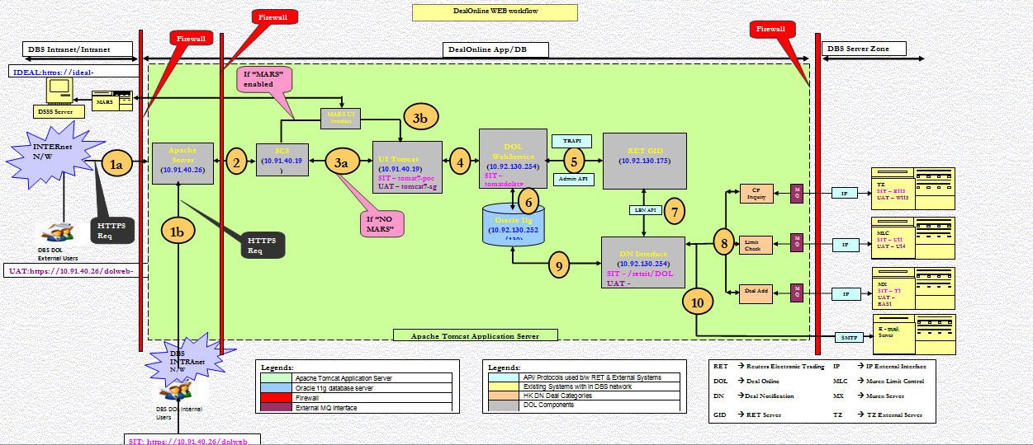

Open the Document for full view 

## Apache server

The apache server acts as a load balancer for DOLWEB application. All user requests are routed through Apache server which in turns redirects the request to appropriate SCS server based upon each server load.

## SCS

## UI Tomcat

All the User Interface pages for DOL application is bundled and deployed in this server. Whatever the operation initiated by user in UI will be captured and corresponding web service in DOLWEB Service (List of services highlighted below) will be called to return the result.

## DOL Web Service

DOL Web Service exposes many web services (SOAP) for all type of user operation required for FX trading for example user profile, user authentication, deal booking, deal inquiry, etc. Once a user successfully authenticated, home page should have all user preferences like username, list of currency pairs of trading, rate box (preferred currencies view on home page), language selection, blotter, etc. Below are the list of web services it expose and its purpose.

|  |  |  |  |
| --- | --- | --- | --- |
| **#** | **WS function Name** | **Input** | **Output** |
| 1 | callgetUserAuthentication | *UserLoginAuthRequest:* username userExternalID region | *UserLoginAuthResponse*: username userExternalID region guid |
| 2 | callGetUserLoginRegion | *UserLoginRegionRequest:* username userExternalID | *UserLoginRegionResponse:* username regionName fullName userExternalID userType fax defaultLang ackFlag defaultAccount |
| 3 | callGetUserProfile | *UserProfileRequest:* region username userExternalID | *UserProfileResponse:* serverTime username accounts regComplianceCode underlyingCode instruments ccys profileCCYGroups dealInfoResult canStreamRates canViewRatesPanel canInitiateChat defaultCCY userLongname userShortname userCIN allowedDealTypes interval settlementInstructions cityBranchItem nonRETUISetting tierUsers allowableCCYs holidayItems |
| 4 | callSubmitDealService | *SubmiDealRequest:* username dealType instrument buySell termsCurrency baseCurrency tenorType takerCustom dealAmount dealtCCY valueDate startTenorType endTenorType startValueDate endValueDate nearLeg farLeg remarks custAccount region | *SubmitDealResponse:* submitDealUserID submitDealID dealStatus |
| 5 | callGetTraderPriceService | *TraderPriceRequest:* dealUserID dealID region | *TraderPriceResponse:* dealUserID dealID traderID traderPrice traderFwdPts traderSpot acceptDelay dealStatus traderNearLegAllIn traderNearLegFwdPts traderNearLegSpot traderNearContraAmt traderNearDealtCCY traderFarLegAllIn traderFarLegFwdPts traderFarLegSpot traderFarContraAmt traderFarDealtCCY contraAmt swapPts dealtCCY riskAmt private int timeoutInterval |
| 6 | callActionOnTraderPriceService | *ActionOnTraderPriceRequest:* isAccept dealUserID dealID traderID region | *ActionOnTraderPriceResponse:* dealUserID dealID traderID action dealStatus |
| 7 | callGetBlotterDeals | *BlotterDealsRequest:* region username | *BlotterDealsResponse:* dealDate cetsID tzReferenceNumber mxReferenceNumber makerOrderReference baseCurrency termsCurrency strTxnType marketRate clientRate strAmt type takerOrderCustom dealStatus  retDealStatus dealTime account  clientID  contraAmount dealtAmount dealtCurrency  instrument  valueDate  baseDirection  riskDate  memo allInRate takerName timeOptionStartValueDate timeOptionEndValueDate |
| 8 | callGetSettlementInstruction | *SettlementInstructionsRequest:* region | *SettlementInstructionsResponse:* settlementType processingBranch settlementID |
| 9 | callUpdateRETPreferenceRequest | *UserUpdateProfileRequest:* region username userExternalID username accounts regComplianceCode underlyingCode instruments ccys profileCCYGroups dealInfoResult canStreamRates canViewRatesPanel canInitiateChat defaultCCY userLongname userShortname userCIN allowedDealTypes interval settlementInstructions cityBranchItem nonRETUISetting tierUsers allowableCCYs holidayItems | *UserUpdateProfileResponse:* isSuccess errorMsg errorCode |
| 10 | callUpdateUIPreferenceRequest | *UserUpdateProfileRequest:* region username userExternalID username accounts regComplianceCode underlyingCode instruments ccys profileCCYGroups dealInfoResult canStreamRates canViewRatesPanel canInitiateChat defaultCCY userLongname userShortname userCIN allowedDealTypes interval settlementInstructions cityBranchItem nonRETUISetting tierUsers allowableCCYs holidayItems | *UserUpdateProfileResponse:* isSuccess errorMsg errorCode |
| 11 | callWithdrawDealService | *WithdrawDealRequest:* dealUserID region | *WithdrawDealResponse:* dealStatus |
| 12 | getAllowableCCYs | *AllowableCCYRequest:* region username | *AllowableCCYResponse:* ccys |
| 13 | getDealLog | *DealLogRequest:* region orderID startDate endDate username startValueDate endValueDate limitRecordCount mxReferenceNo tzReferenceNo pageSize orderIDs instrument | *DealLogResponse:* dealDate cetsID tzReferenceNumber mxReferenceNumber makerOrderReference baseCurrency termsCurrency strTxnType marketRate clientRate strAmt type takerOrderCustom dealStatus  retDealStatus dealTime account  clientID  contraAmount dealtAmount dealtCurrency  instrument  valueDate  baseDirection  riskDate  memo allInRate takerName timeOptionStartValueDate timeOptionEndValueDate |
| 14 | callGetRandomResearch | *GetRandomResearchRequest:  region count* | *GetRandomResearchResponse:* researchList id title size country path private DataHandler content private Date createdOn summary imgUrl |
| 15 | callGetRandomNews | *GetRandomNewsRequest:* region newsCount | *GetRandomNewsResponse:* newsList id headline story private Calendar storyDate keywords |
| 16 | callGetAllNews | None | *GetAllNewsResponse:* newsList id headline story private Calendar storyDate keywords |
| 17 | callGetAllQuotes | None | *GetAllQuotesResponse:* quoteList id name rate change date time percentChange |
| 18 | callDealInfoService | *DealInfoRequest:* ccypairs instrument region | *DealInfoResponse:*  tenor valueDate |
| 19 | callGetHolidaysInfo | *HolidayInfoRequest:* ccy tenor | *HolidayInfoResponse:* currency holidayDateList |
| 20 | callGetCityBranchInfo | *CityBranchRequest:* username userExternalID region | *CityBranchResponse:* branchCode cityCode branchName initCode |
| 21 | callAuthentication | *AuthenticationRequest:* username password region pin token ADAuthentication DSSSAuthentication | *AuthenticationResponse:* authorizedLogin sessionID sessionKey |
| 22 | callGetNewsByCriteria | *GetNewsByCriteriaRequest:* region newsCount keywords fromTime toTime retrieveStory | *GetNewsByCriteriaResponse:* newsList id headline story private Calendar storyDate keywords |
| 23 | callGetNewsStory | *GetNewsStoryRequest:* newsID | *GetNewsStoryResponse:* news |
| 24 | callGetHistoricalRates | *GetHistoricalRatesRequest:* ccyPair startTime endTime | *GetHistoricalRatesResponse:* historicalRates ccyPair updateDate openingRate closingRate highestRateOfDay lowestRateOfDay |
| 25 | callGetCreditCheckStatus | *GetCreditCheckStatusRequest:* region dealUserID clearFlag | *GetCreditCheckStatusResponse:* dealUserID |
| 26 | generateTestHistoricalData | None | None, it just update the db with historical data |
|  |  |  |  |
|  |  |  |  |

These web services intern calls the TrAPI / Admin Api to perform the desired operation.

## Deal Notification Interface

DN act as a gateway between RET back end server and IP for routing the deal messages (e.g. Deal Notification and Credit Check). The connection between DN and RET will be via API method calls (LBN API which is provided by vendor Thomson Reuters)The connection between DN and IP will be via Message Queue (MQ).

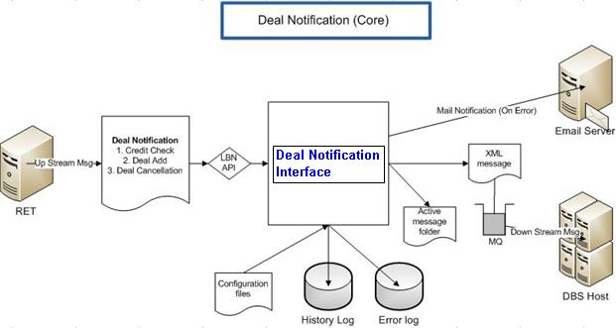

The RET Deal Notification Interface program integrates RET with Murex via IP, it enables the following functionalities.

1. For the Deal Notification, “RET” will send 3 different up stream messages: Credit Check request, Deal Creation and Deal Reversal notification to Murex via IP layer.
2. The “Interface Program” will retrieve these messages from “RET” through Reuters API called LBNAPI.
3. The interface program will read the “Configuration file” to get the login and currency information. The password is in the encrypted format.
4. Message Queue (MQ) will be used for communication between “Interface Program” and Murex. Two Local MQs will be setup. One for request and one for response for each region.
5. An “XML message” will be formatted and pass to Local request queue for delivering to Murex as downstream message. At the same time the message will export to message log file and store in a folder. This serves as a token for all active messages.
6. The interface program waits for a response message from the local response queue. If there is any error, the interface program writes the error into “error log” file. And then send a “mail notification” message to “email server”.

## Orale DB server

## IP Layer

## Message Queue

# DOLWEB Class Diagram

The following diagram illustrates the static relationships of all the components/modules in the DOL WS system.



The following table shows the interface layout of DOL WS System:

|  |  |  |  |  |
| --- | --- | --- | --- | --- |
| Interfacing System | Input or Output | Protocol | Format / Media | Purpose |
| RETTrapiProxyService | - | Java method call | - | The main application of web services interface |
| RETTrapiProxyImpl | - | Java method call | - | The implementation for RETTrapiProxyService interface |
| RETServiceInvoker | - | Java method call | - | The main business logic to direct to different interfaces |
| Dao(package) | - | Java method call | - | A package of classes the call to DB. |
| Adaptor(package) | Java Stub Object from RET | Java method call | - | A package of classes to handle the asynchronous call from RET and adapt to the business logic of DOL |
| Connector(package) | - | Java method call | - | A package of classes to handle the connection to call to RET Engine |
| ValidationException | - | Java method call | - | A class that handles only validation exception |
| AdaptorExceptionException | - | Java method call | - | A class that handles only adaptor exception |
| DAOException | - | Java method call | - | A class that handles only dao exception |
| Util(package) | - | Java method call | - | A package of classes as utility to help others classes |
| Helper(package) | - | Java method call | - | A package of classes as helper classes for other class in case the implementation is too complicated. |
| Constant(package) | - | Java method call | - | A package of classes to specify constant |
| Validation(package) | - | Java method call | - | A package of classes to validation of the SOAP request |
| Filter(package) | - | Java method call | - | A package of classes to handle the furnish on request or response before processing or sending out |
| RETTrapiProxyInitListener | - | Java method call | - | A class to initialize the WS Web application. |
|  |  |  |  |  |

# DOLWEB Deal Submission flow:

The below screenshots highlights the deal submission flow of DOLWEB application.

Login:

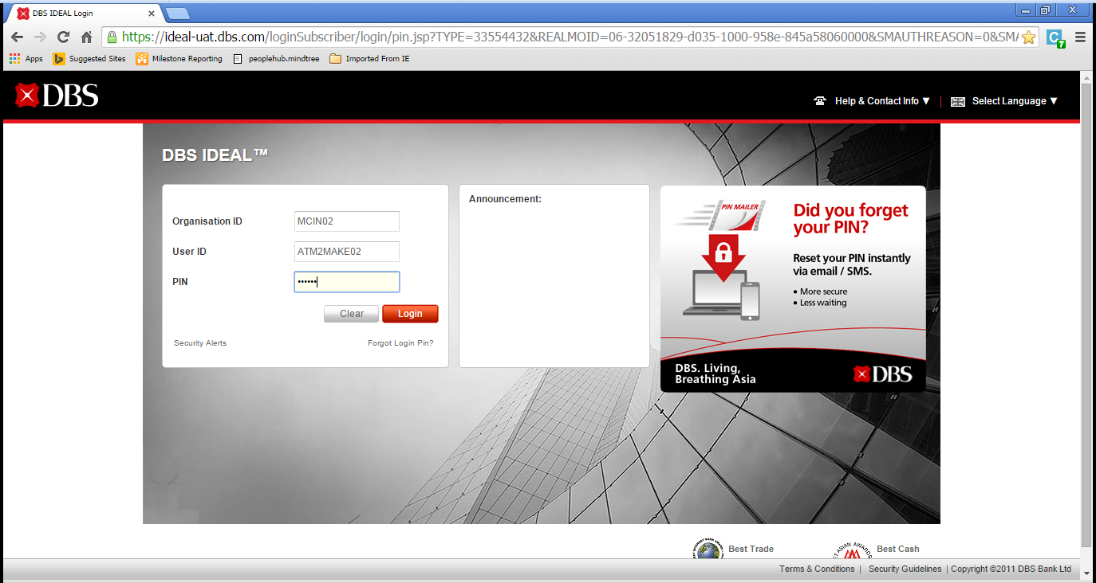

Ideal landing page:

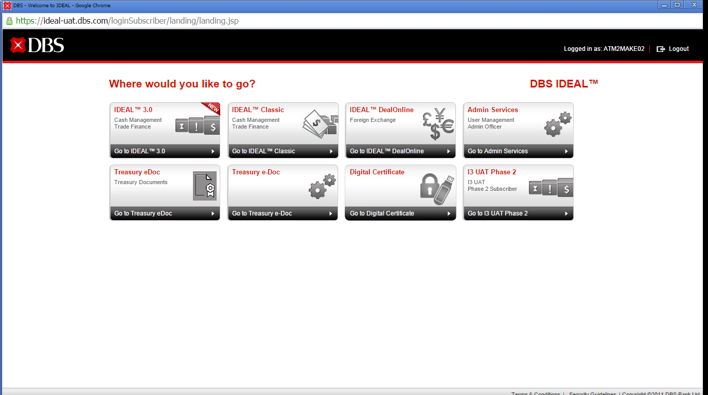

Region selection page (if the user has accounts in more than one region)

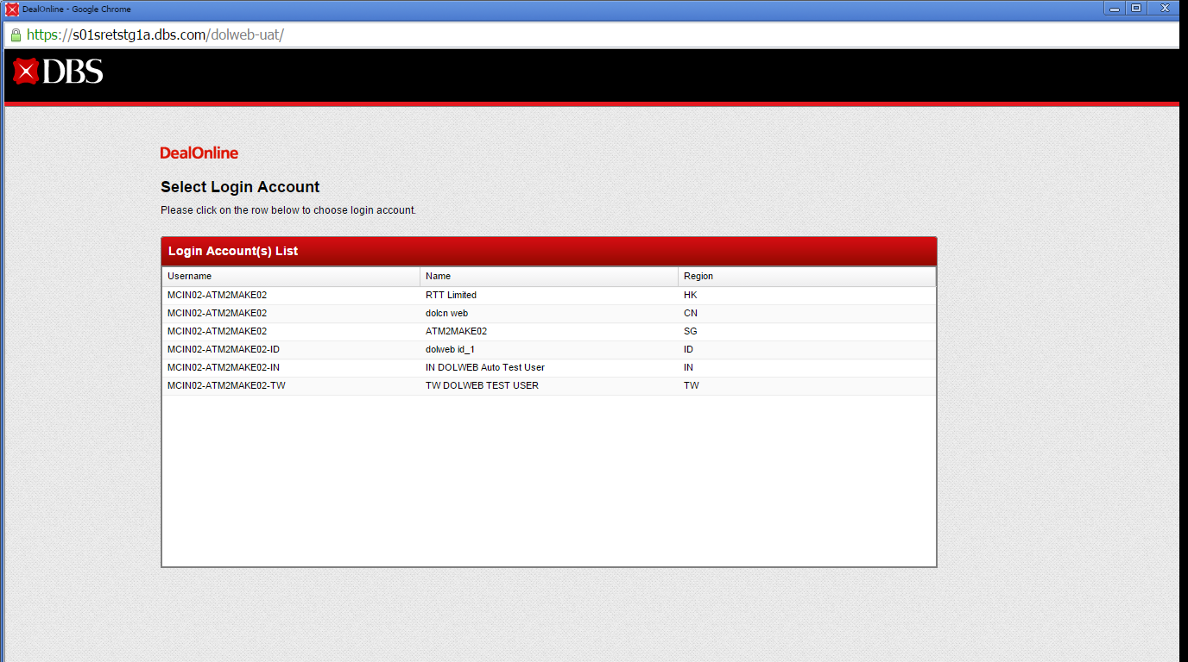

T&C page

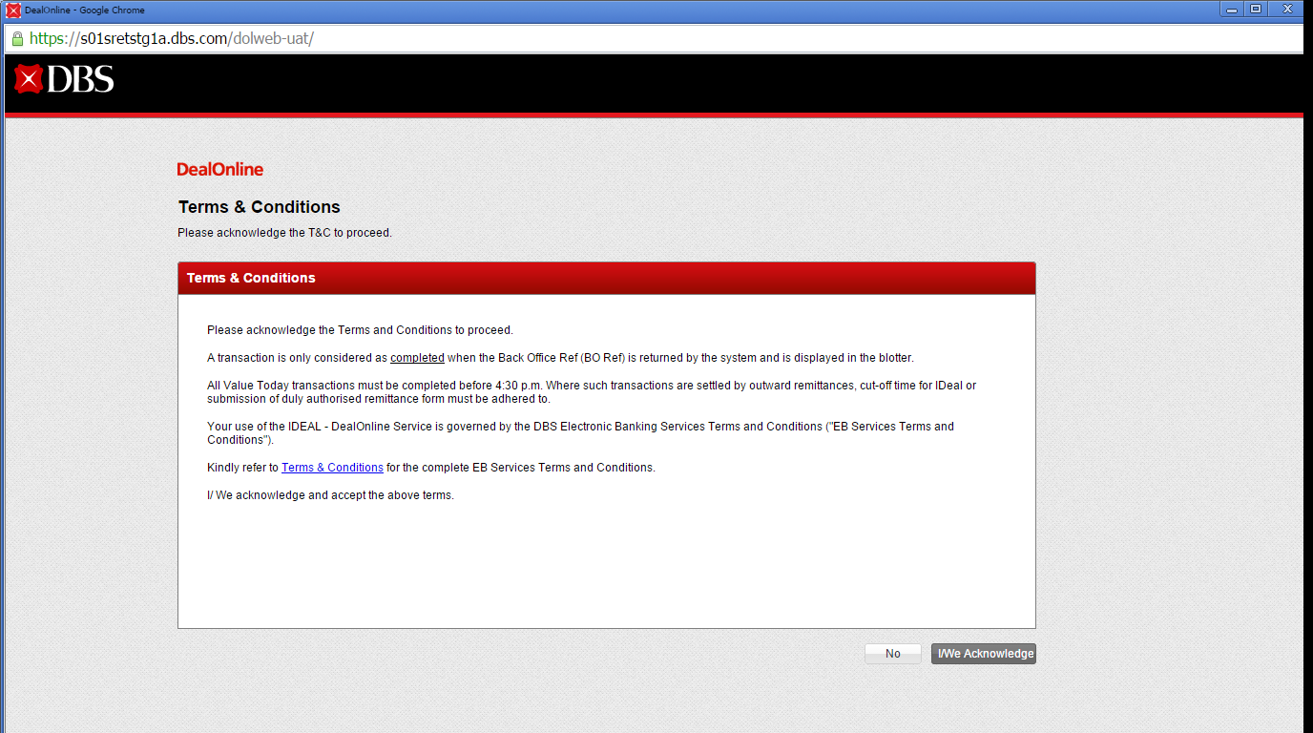

DOLWEB home page:

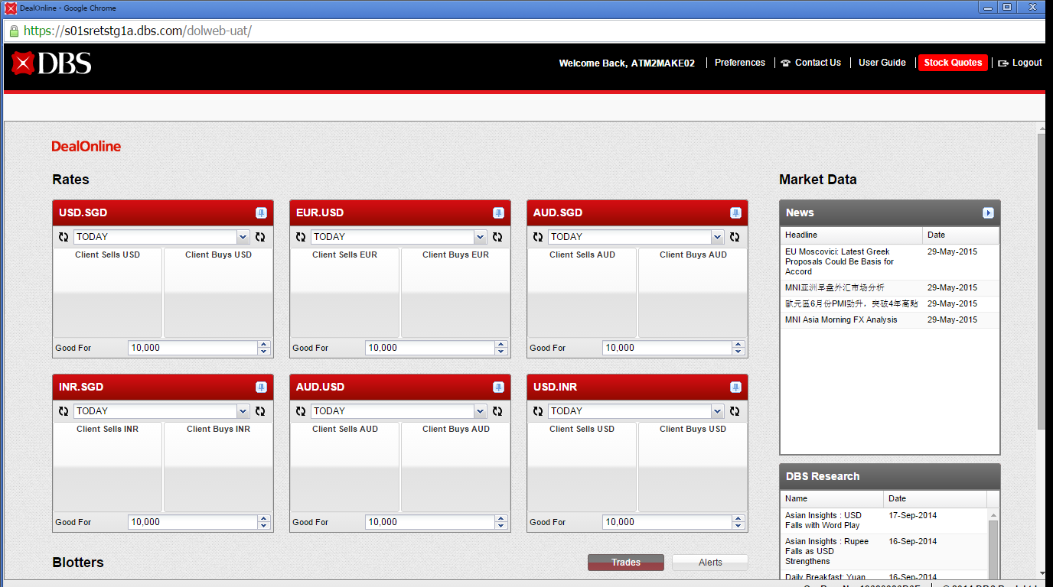

**On clicking on Preference page:**

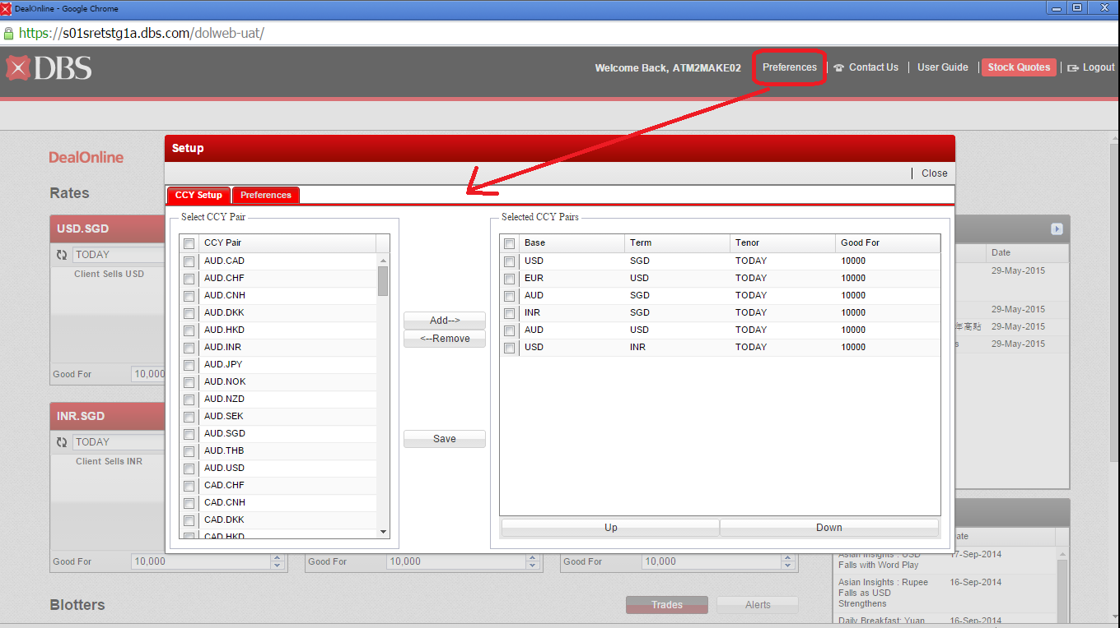

**Deal ticket for FX deal submission**

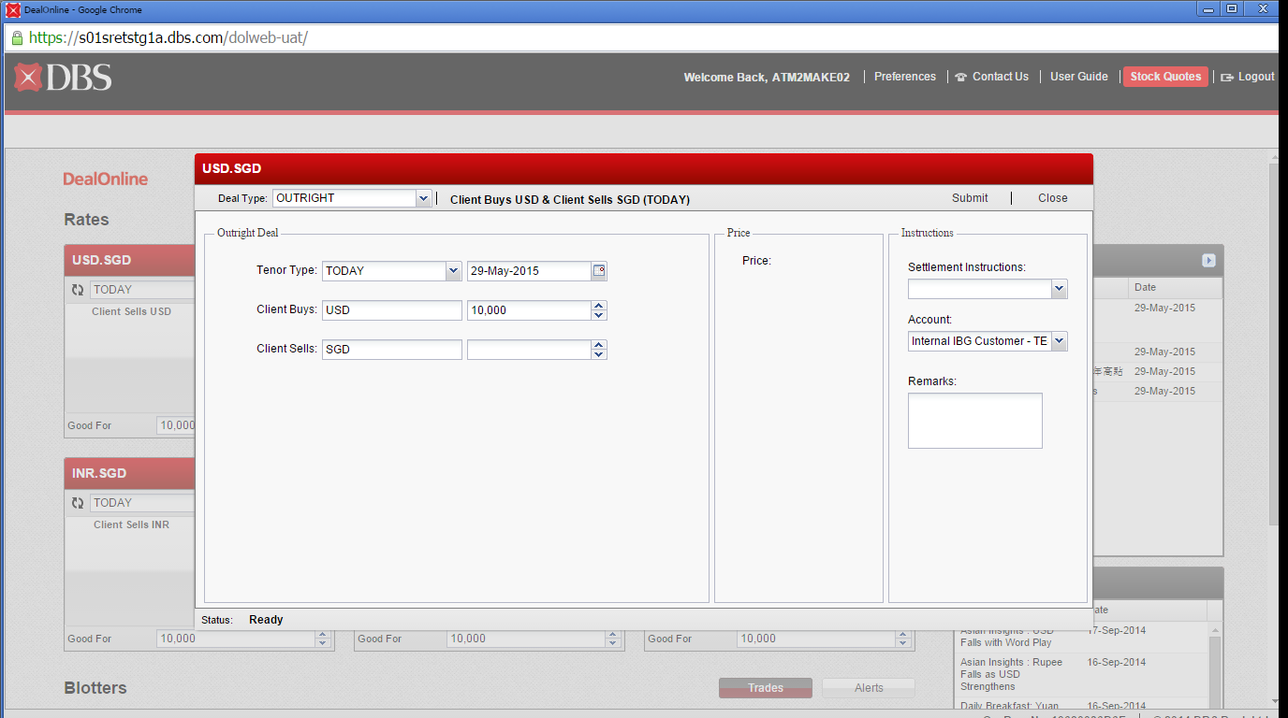

**Quote Rate or Trade price to “Acknowledge”:**

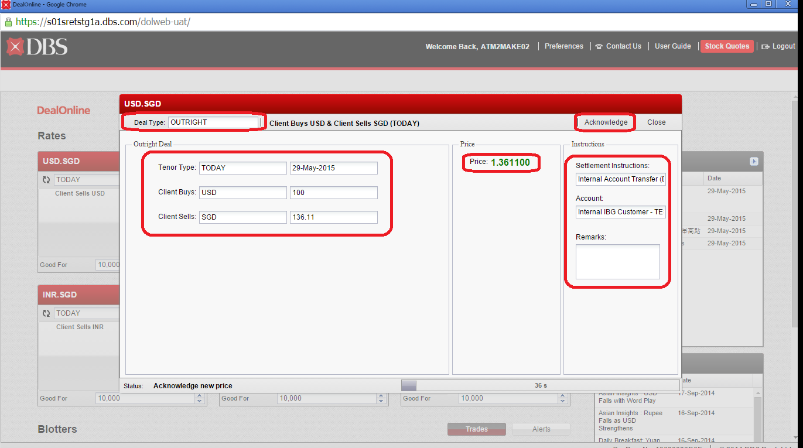

**Execute Quote Rate or Submit deal to “Accept”:**

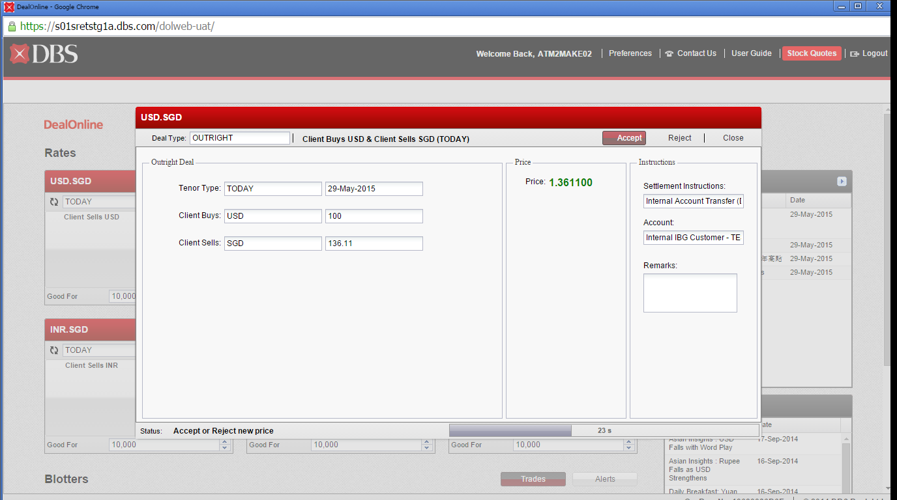

**Deal Confirmation Page:**

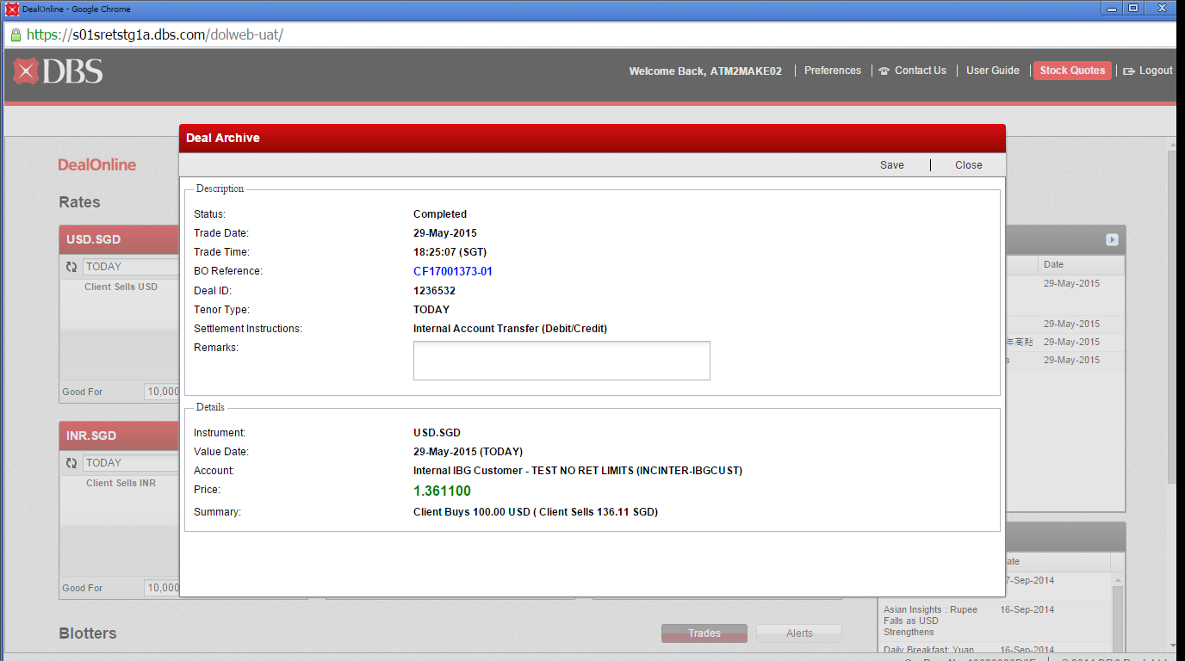

**Deal Blotter:**

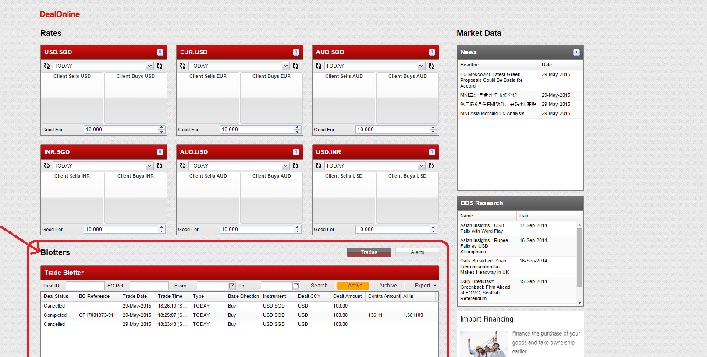

**Market Data/ DBS Research**

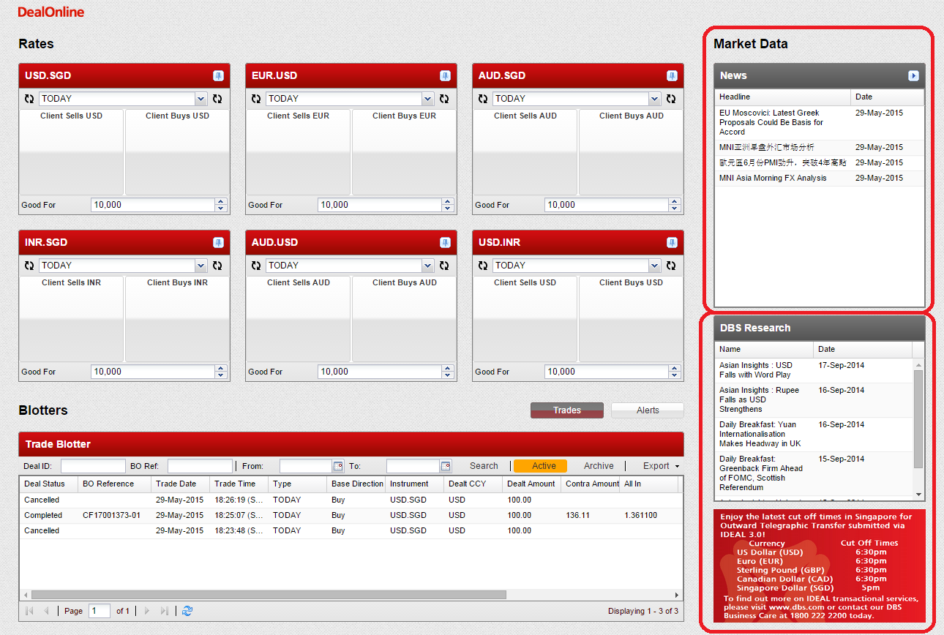

# DOLWEB Admin & CMT setup guide:

DOLWEB Admin setup is a set of process that needs be followed when user comes on board for any FX deal booking. This admin setup is maintained by T & M and CMT team hands the user on-board requests. The following document highlights the admin setup and Channel Management Team (CMT) setup for Indonesia region.

**Indo Admin Setup:**



**Indo CMT setup:**



# DOLWEB CMT Reports

This section covers the following CMT report:

1. Audit Trail Setup Report
2. Pending Completion Report
3. AdminID Login Report
4. User Creation Report

## DOL WEB – CMT Reports Module 1: Audit Trail and Pending Completion Report

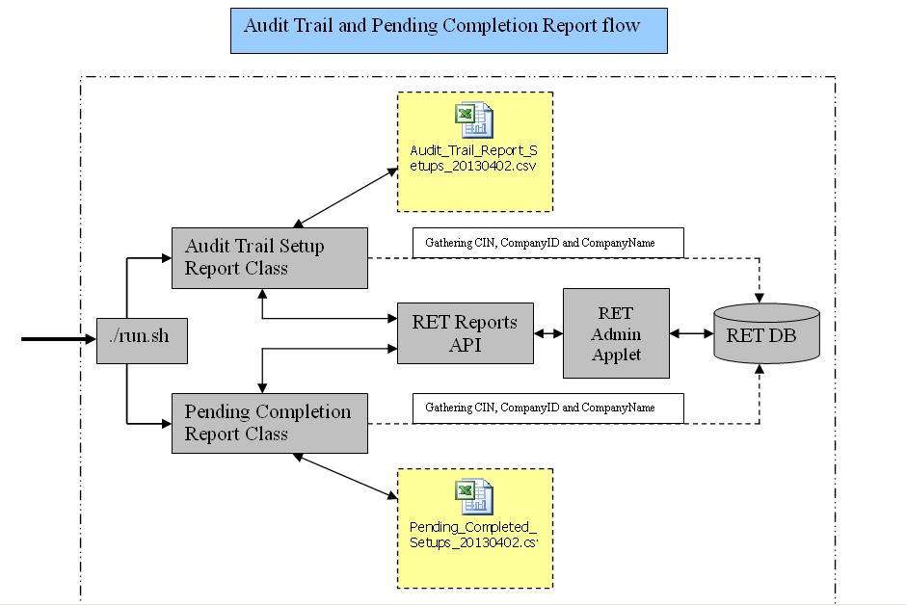

The above module uses the existing RET Audit Trail report code base and enhanced based on the DOL WEB CMT reports requirement (refer BR#1, #6).

## DOL WEB – CMT Reports Module 2: AdminID Login and User Creation Report

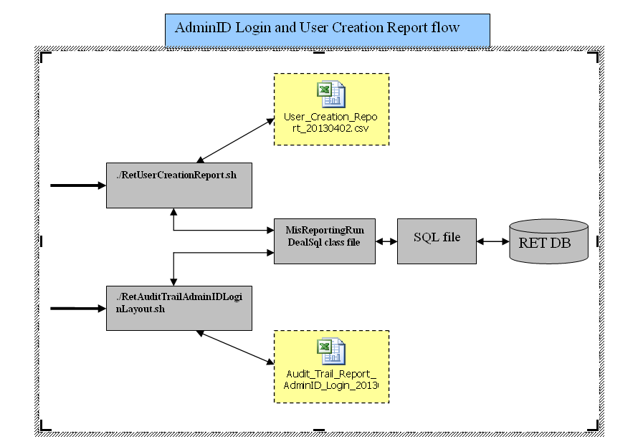

The above module uses the existing MIS Reporting code base and enhanced based on the DOL WEB CMT reports requirement (refer BR#29).

The following table highlights the required components and properties details of CMT Reports:

|  |  |  |  |  |
| --- | --- | --- | --- | --- |
| Report Module | Class/ Properties | Package/ Location | Protocol / Format / Media | Purpose |
| Module 1 | run.sh | /retuat/dbshk/report/dolweb_audittool_report | Shell Script | A script which helps to initiate the execution of Audit Trail and Pending Completion Report |
| Main.java | com.dbs.ret.adt | Java method call | The main class which initiates the Audit Tool program |
| AdminAuditTool.java | com.dbs.ret.adt.admin | Java method call | A class helps to generate Admin Audit Trail report |
| AdminAuditToolPendingCompletion.java | com.dbs.ret.adt.admin | Java method call | A class helps to generate Pending Completion report |
| adminreportutil.properties | Directly under project-root | Property file | A property file holds the details of user credentials, report format, input parameter, location, etc. |
| overallconfig.properties | Directly under project-root | Property file | A property file holds the details of report location, report name, email account details such To, CC, Subject, etc., |
| reports.ini | Directly under project-root | Property file | A property file holds the RET Admin Applet connection details |
|  |  |  |  |  |
| Module 2 | RetUserCreationReport.sh | /retuat/dbshk/report/dolweb_report/bin | Shell Script | A script which helps to initiates the execution of User Creation Report |
| RetAuditTrailAdminIDLoginLayout.sh | /retuat/dbshk/report/dolweb_report/bin | Shell Script | A script which helps to initiates the execution of AdminID Login Report |
| extractUserCreationHK.sql | /retuat/dbshk/report/dolweb_report/properties | SQL file | A SQL file helps to execute against the RET DB to generate the output for User Creation Report |
| extractUserCreationCN.sql | /retuat/dbshk/report/dolweb_report/properties | SQL file | A SQL file helps to execute against the RET DB to generate the output for User Creation Report |
| auditTrailAdminID_HK.sql | /retuat/dbshk/report/dolweb_report/properties | SQL file | A SQL file helps to execute against the RET DB to generate the output for AdminID Login Report |
| auditTrailAdminID_CN.sql | /retuat/dbshk/report/dolweb_report/properties | SQL file | A SQL file helps to execute against the RET DB to generate the output for AdminID Login Report |
| MisReportingRunDealSql.java | com.dbs.retsg.cis.misReporting | Java method call | A class that helps to generate AdminID login and User Creation report |
| MisReportingDeal.properties | Directly under project-root | Property file | A property file that holds the details of RET DB connection |

# Report Execution:

Location for different regions CMT report: /retuat/data/install/CR_DOL/DOL/

Location of region CMT report: /retuat/data/install/CR_DOL/DOL/report_<2 letter region code>

Location of CMT Report script: /retuat/data/install/CR_DOL/DOL/report_id/sendCMTReport.sh

# Reference Code Specification

## Audit Trail and Pending Completion Reports Properties

### adminreportutil.properties

com.reuters.sample.reporting.user=admin5

com.reuters.sample.reporting.secureid=

com.reuters.sample.reporting.password=d

com.reuters.sample.reporting.transform=raw_csv.xsl,raw_txt.xsl

com.reuters.sample.reporting.transform_only=N

com.reuters.sample.reporting.outputfile=../reports/Audit_Trail_Report_Setups_**{0}**.xml

com.reuters.sample.reporting.transform.outputfiles=../reports/Audit_Trail_Report_Setups_RAW_**{0}**.csv,../reports/Audit_Trail_Report_Setups_RAW_**{0}**.txt

com.reuters.sample.reporting.transform.include=true,true

com.reuters.sample.reporting.readablereport=../reports/Audit_Trail_Report_Setups_**{0}**.csv

com.reuters.sample.reporting.reportname=AUDIT

com.reuters.sample.reporting.reportparameters.0.name=day

com.reuters.sample.reporting.reportparameters.0.value=20130327

com.reuters.sample.reporting.reportparameters.0.predicate=EQ

#com.reuters.sample.reporting.reportparameters.0.name=range

#com.reuters.sample.reporting.reportparameters.0.value=20110602060000-20110602235900

#com.reuters.sample.reporting.reportparameters.0.predicate=DATERANGE

######### Pending Completion Audit Report ##################

com.reuters.sample.reporting1.user=admin2

com.reuters.sample.reporting1.secureid=

com.reuters.sample.reporting1.password=d

com.reuters.sample.reporting1.transform=raw_csv.xsl,raw_txt.xsl

com.reuters.sample.reporting1.transform_only=N

com.reuters.sample.reporting1.outputfile=../reports/Pending_Completed_Setups_**{0}**.xml

com.reuters.sample.reporting1.transform.outputfiles=../reports/Pending_Completed_Setups_RAW_**{0}**.csv,../reports/Pending_Completed_Setups_RAW_**{0}**.txt

com.reuters.sample.reporting1.transform.include=true,true

com.reuters.sample.reporting1.readablereport=../reports/Pending_Completed_Setups_**{0}**.csv

com.reuters.sample.reporting1.reportname=AUDIT

com.reuters.sample.reporting.reportparameters.0.name=day

com.reuters.sample.reporting.reportparameters.0.value=20130327

com.reuters.sample.reporting.reportparameters.0.predicate=EQ

#com.reuters.sample.reporting1.reportparameters.0.name=range

#com.reuters.sample.reporting1.reportparameters.0.value=20110602060000-20110602235900

#com.reuters.sample.reporting1.reportparameters.0.predicate=DATERANGE

###############################################################

# SIT Database Setup

###############################################################

#db.name.key=RETHK

#db.hostname.RETHK=10.92.130.252

#db.port.RETHK=1521

#db.username.RETHK=retsit3

#db.passwordProvider.RETHK=com.dbs.ret.adt.util.HardcodePasswordProvider

#db.passwordProvider.RETHK=com.dbs.ret.cryptoProvider.RETCryptoDBPasswordProvider

#db.serviceName.RETHK=RETSIT

###############################################################

# UAT Database Setup

###############################################################

db.name.key=RETHK

db.hostname.RETHK=10.92.130.130

db.port.RETHK=1521

db.username.RETHK=rethk

db.passwordProvider.RETHK=com.dbs.ret.adt.util.HardcodePasswordProvider

#db.passwordProvider.RETHK=com.dbs.ret.cryptoProvider.RETCryptoDBPasswordProvider

db.serviceName.RETHK=retuat3

### overallconfig.properties

report.dir=../retuat/dbshk/data/

admin.audit.enable=yes

overriderade.audit.enable=no

ratemonitor.aduit.enable=no

mail.enable=true

mail.smtp.host=w01s1bnksmt01.reg1.uat1bank.dbs.com

mail.from=DealOnlineAppSupport@uat1bank.dbs.com

mail.to=saralynmejia@uat1bank.dbs.com

mail.cc=DealOnlineAppSupport@uat1bank.dbs.com

mail.subject=DOL WEB HK Audit Report (Auto-Generated on **{0}**)

mail.body=DOL WEB HK Audit Report attached \n password will be sent in a separate email

mail.error.subject=DOL WEB HK audit report job fail

mail.error.body=DOL WEB HK audit report job fail

mail.subject.password=Password to DOL WEB HK Audit Report

mail.to.support=DealOnlineAppSupport@uat1bank.dbs.com

report.password.length=12

report.name=DOL_WEB_HK_AuditReport.zip

### reports.ini

USE_SCS=true

RESOURCE=GID.logs

RESOURCE_INFO=HOST:10.92.130.250,TYPE:SOCK_RAW,PORT:8080,HB:10

IDLE_TIMEOUT=50000

REPORT_LIMIT=150

USE_WEBSERVICES=false

NEW_PW_ENC_TYPE=NONE

LICENCE=./lic/reporting_api.lic

## User Creation and AdminID Login Reports Properties

### MisReportingDeal.properties

************************************

* RETDB information

************************************

db.name.key=RET,RETCN

db.hostname.RET=10.91.39.172

db.port.RET=1521

db.username.RET=RET

db.passwordProvider.RET=com.dbs.ret.cryptoProvider.RETCryptoDBPasswordProvider

db.serviceName.RET=RETUAT

db.hostname.RETCN=10.91.39.172

db.port.RETCN=1521

db.username.RETCN=RETCN

db.passwordProvider.RETCN=com.dbs.ret.cryptoProvider.RETCryptoDBPasswordProvider

db.serviceName.RETCN=RETUAT

## CMT Sample Reports

### Audit Trail Setup Report

Please refer to the attached excel for the reference:



### Pending Completion Report

Please refer to the attached excel for the reference:



### Audit Trail AdminID Login Report

Please refer to the attached excel for the reference:



### User Creation Report

Please refer to the attached excel for the reference:

